STREAMLIT PROJECT

BMI Calculator App (Streamlit)

Project Description

This project is a simple and interactive BMI (Body Mass Index) Calculator built using Python and stream lit.

It allows users to enter their height, weight, age, and gender, and then calculates their BMI value, gives a health interpretation (Underweight, Normal, Overweight, or Obese), and also suggests the ideal weight range for their height

Features

• User-friendly web app built with Stream lit

• Input fields for height (cm), weight (kg), age, and gender

• Instant BMI calculation

• Health interpretation (based on WHO BMI categories)

• Shows ideal weight range for the given height

• Clean, professional UI.

CODE:

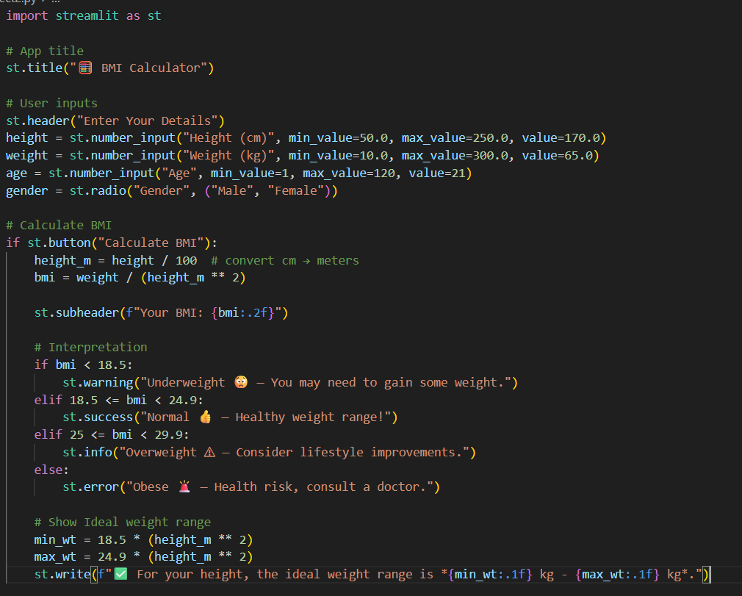

Output: